Dr. Karyn Tunks is coming to Our School!
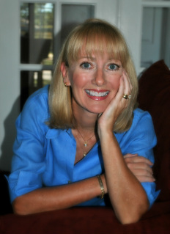
Karyn Tunks, children’s book author, will visit our school on:
Dr. Tunks has written two picture books about Alabama. Copies are being sold in conjunction with the event. Our goal is to preorder 100 books!

Here is more information about the books she will be talking about to the students:

JUBILEE! During this unique and mysterious event along Mobile Bay, marine life washes onto the shore during the night. During a visit to her grandmother’s house, Caroline captures this memorable event with her camera. Illuminating illustrations and a glossary of terms enhance this story of coastal fun.
USS ALABAMA: Hooray for the Mighty A! The battleship has welcomed visitors to Mobile Bay since 1965, but without the help from dedicated schoolchildren, the ship might have been lost forever. Complete with a glossary, illustrated ship diagram and timeline.
If you would like to prepay and order autographed books for your student, please fill out the order form and return to:
Orders must be received by:
Make checks payable to:
Student’s Name ________________________________________________________
Homeroom____________________________________________________________
Title | Number of Copies | Price Per Book | Total Cost
Jubilee! |  | $16.99
USS Alabama: Hooray for the Mighty A! |  | $17.99
Total Number of Books and Cost

